Git Assignment

* Created a repository zemoso-training in my account

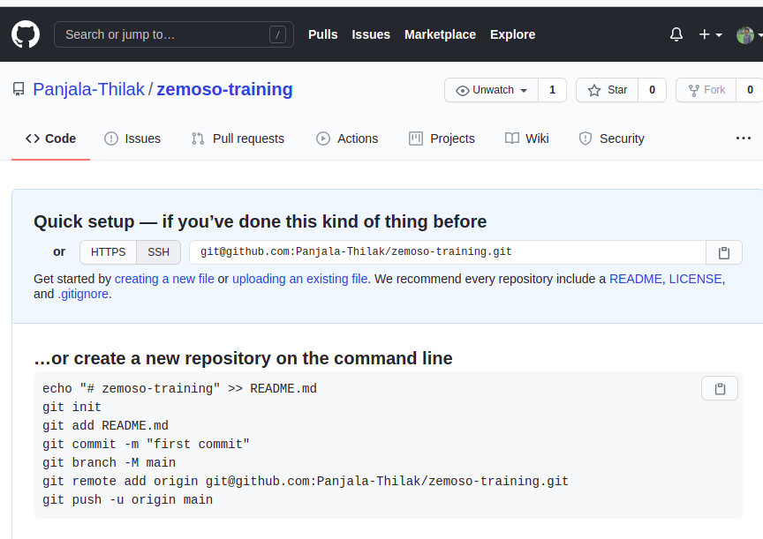

* Created a local repository-first_git_repo 
* git repository is initialized using **git init**
* Created a file hello_world.txt using **gedit hello_world.txt**
* Checked the status using **git status-->**It shows the details of all untracked files

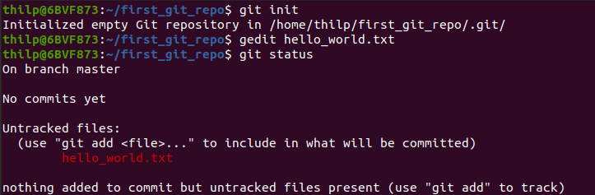

* Hello_world.txt file is added to the staging area by using **git add**
* Checked the status using **git status**
* Committed the changes using **git commit -m “message”**

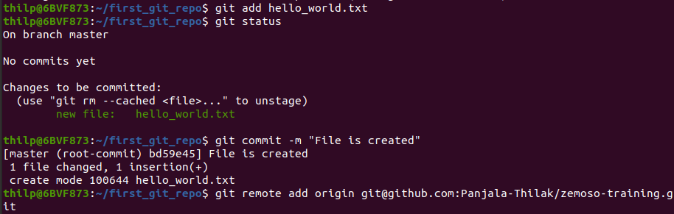

* Added a remote the repository using **git remote**



* Pushed the file into remote repository using **git push -u origin master**

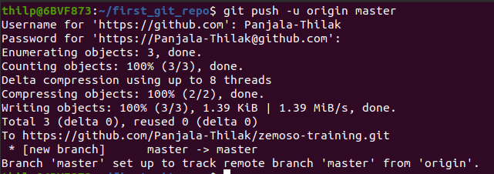

* It is pushed into the github repository

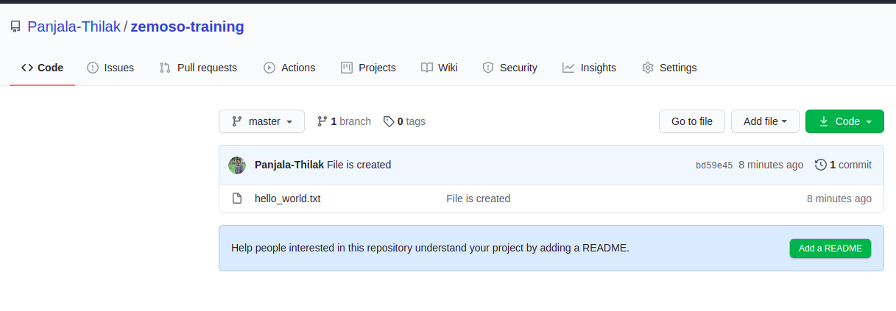

* Replaced ‘to’ with ‘my name’ with the help of sed

**Sed -i ‘s/to/thilak/g’ hello_world.txt**

* Checked the difference using **git diff**

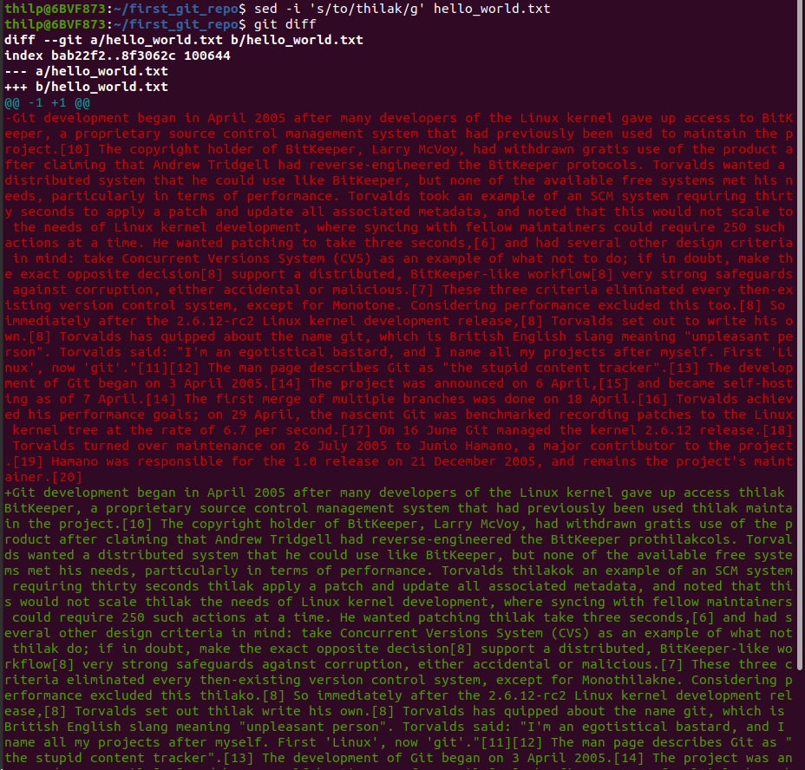

* Hello_world.txt file is added to the staging area by using **git add**
* Committed the changes using **git commit -m “message”**
* Pushed into the remote repository using **git push**

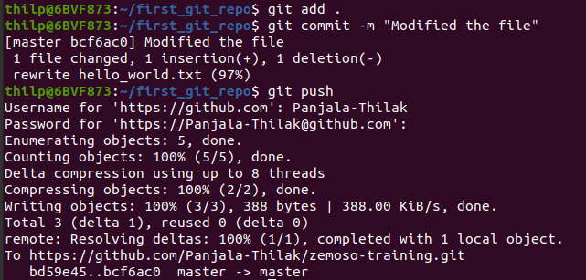

* Checked the commits in my github account

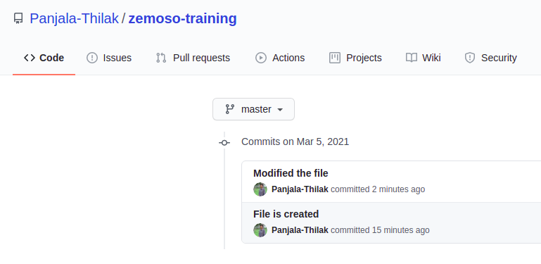

* We can get all the commits by using **git log**
* Then after, I reverted the commit using **git revert hash_id**

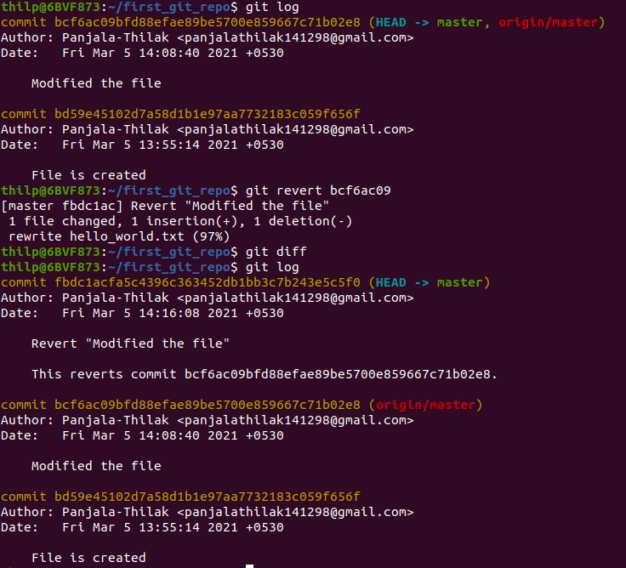

* Created a branch using **git branch branch_name**
* Switched into the branch using **git checkout branch_name**



* Replaced ‘Torvalds’ with ‘my name’ with the help of sed

**Sed -i ‘s/Torvalds/thilak/g’ hello_world.txt**

* Checked the difference using **git diff**

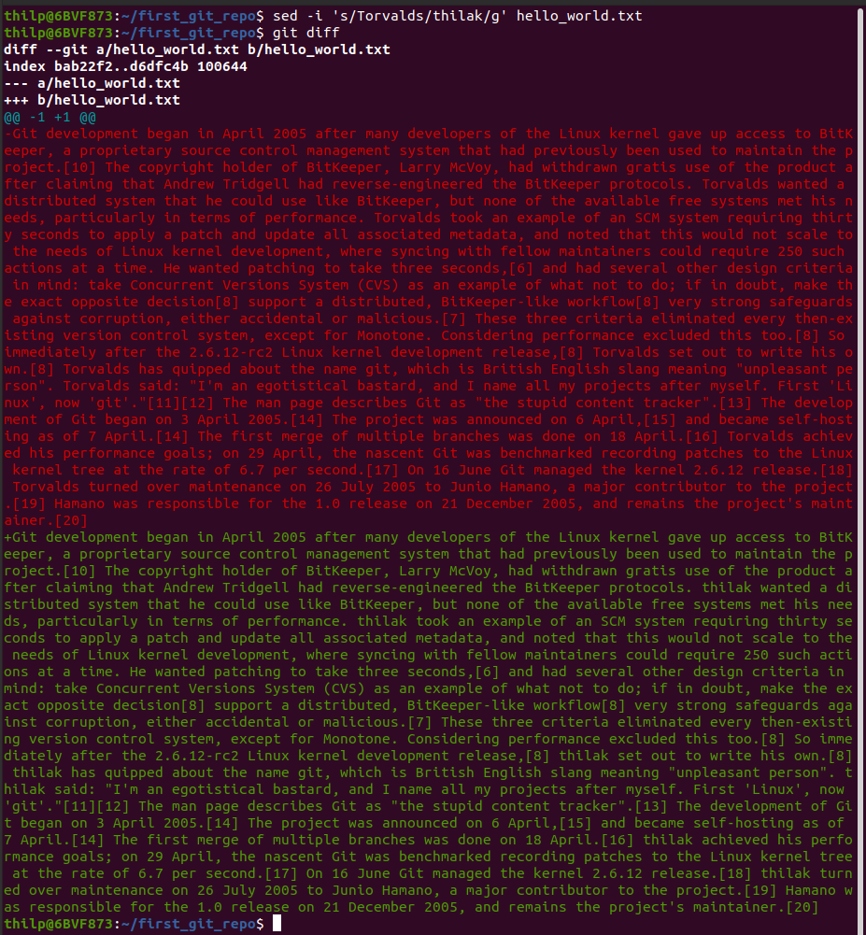

* Checked the status using **git status**
* Added to the staging area by using **git add .**
* Committed the changes using **git commit -m “message”**
* Pushed the file into remote repository using **git push -u origin new_branch**

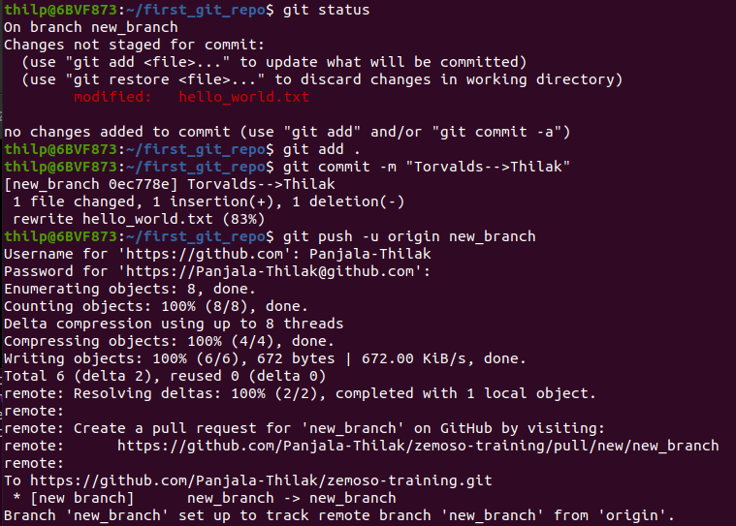

* Switched into the master using **git checkout master**
* Pull request is raised using **git pull origin master-->**to know whether any updates have been made.
* Merged the new_branch using **git merge new_branch**
* Pushed the file into remote repository using **git push**

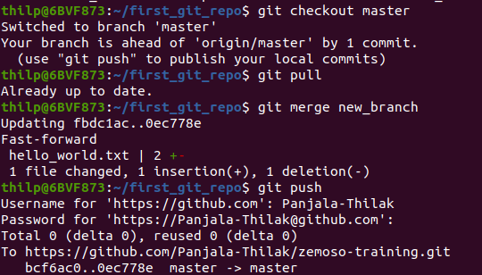

* Created a local repository git_clone_repo
* Cloned the main repository on my github to this folder using

**git clone**

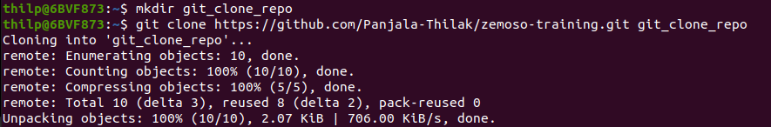

**URL of my Git repository**

<https://github.com/Panjala-Thilak/zemoso-training>